Traffic Sign DETECTION
PACKAGE DOCUMENTATION
ROS 2 object detection using YOLOv8 and an OAK-D stereo camera
Developer Documentation
Version 1.0
Date: July 2026

Table of Contents
1. Introduction
2. System Architecture
3. Installation
4. Running the Package
5. Package Structure
6. Package Responsibilities
7. ROS Topics
8. Custom Messages
9. Detection Pipeline
10. Distance Estimation
11. Future Improvements

1. Introduction

Purpose
This package performs real-time traffic sign detection using a custom-trained YOLOv8 model running on an NVIDIA Jetson platform. It subscribes to RGB images from an OAK-D camera, performs inference using Ultralytics YOLOv8, estimates object distance using the stereo depth image, visualizes detections, and publishes the results as ROS 2 topics.
The package has been designed with modularity in mind so that new developers can easily:
- Replace the detection model
- Add new classes
- Change visualization
- Integrate with navigation
- Integrate with Behaviour Trees
- Integrate with planning modules

Features
✓ Real-time YOLOv8 inference
✓ GPU acceleration (CUDA)
✓ Custom trained model
✓ Stereo depth estimation
✓ Bounding box visualization
✓ Confidence estimation
✓ Distance estimation
✓ ROS2 message publishing
✓ Modular architecture

Software Stack
Component | Version
Ubuntu | 22.04
ROS2 | Humble
Python | 3.10
PyTorch | CUDA enabled
Ultralytics | YOLOv8
OpenCV | 4.x
OAK-D Camera | DepthAI

2. System Architecture
The diagram below shows how image and depth data move through the package, from camera capture to published detections.
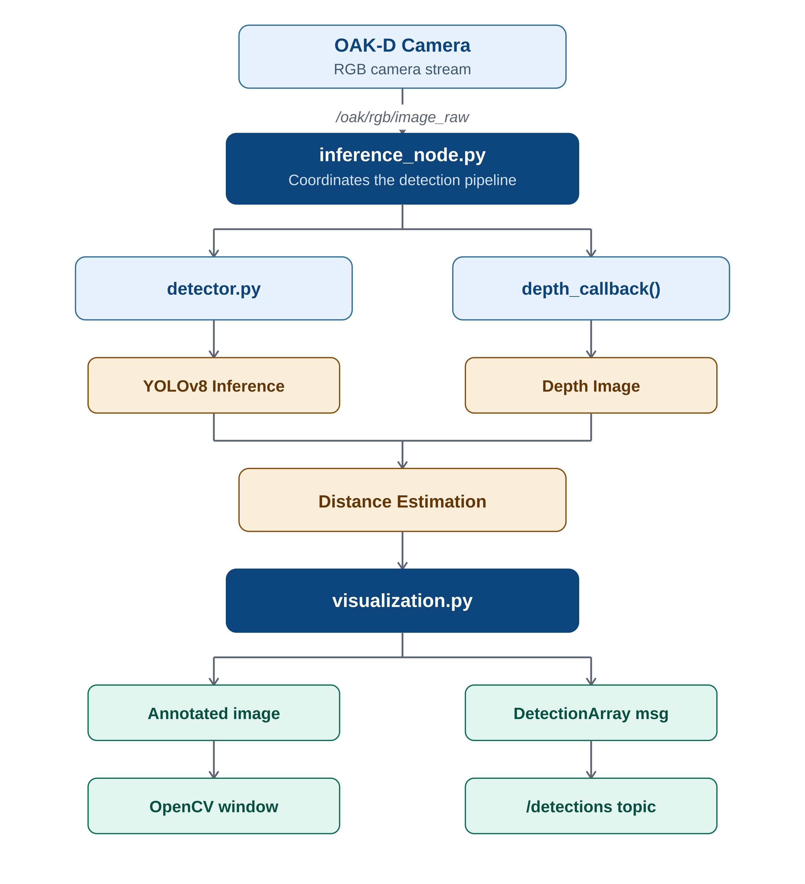
Figure 1 — Object detection system architecture

3. Installation
This chapter describes how to install the object detection packages into a ROS 2 Humble workspace.

Prerequisites
The following software should already be installed on the system.
Software | Version
Ubuntu | 22.04
ROS2 | Humble
Python | 3.10
OpenCV | 4.x
PyTorch | CUDA enabled
Ultralytics | YOLOv8
DepthAI ROS Driver V3 | Installed
OAK-D Camera | Connected

Package Files
The project consists of two ROS2 packages:
object_detection.zip
object_detection_msgs.zip
Package | Description
object_detection | Performs YOLO inference, distance estimation, visualization, and publishes detections.
object_detection_msgs | Defines the custom ROS2 messages used by the object detection package.

Create a ROS2 Workspace
If a ROS2 workspace does not already exist, create one.
mkdir -p ~/ros2_ws/src
cd ~/ros2_ws

Copy and Extract the Packages
Copy both zip files into the src directory, then extract them.
cd ~/ros2_ws/src
unzip object_detection.zip
unzip object_detection_msgs.zip

After extraction, the workspace should contain:
ros2_ws/
└── src/
├── object_detection/
└── object_detection_msgs/

Verify Package Structure
The workspace should contain:
ros2_ws/
└── src/
├── object_detection/
│ ├── package.xml
│ ├── setup.py
│ ├── object_detection/
│ ├── launch/
│ └── models/
│
└── object_detection_msgs/
├── package.xml
├── CMakeLists.txt
└── msg/
├── Detection.msg
└── DetectionArray.msg

Build and Source the Workspace
Return to the workspace root and build the packages.
cd ~/ros2_ws
colcon build
Expected output:
Starting >>> object_detection_msgs
Starting >>> object_detection
Finished <<< object_detection_msgs
Finished <<< object_detection
Summary: 2 packages finished
After every successful build, source the workspace.
source install/setup.bash
To avoid sourcing it manually every time a new terminal is opened, add it to the shell configuration file.
echo "source ~/ros2_ws/install/setup.bash" >> ~/.bashrc
source ~/.bashrc

Verify Installation
Ensure that ROS2 can locate both packages.
ros2 pkg list | grep object_detection
Expected output:
object_detection
object_detection_msgs
Verify that the custom messages have been generated correctly.
ros2 interface show object_detection_msgs/msg/Detection
Expected output:
std_msgs/Header header
string class_name
uint16 class_id
float32 confidence
float32 distance
int32 xmin
int32 ymin
int32 xmax
int32 ymax
If the message definition is displayed correctly, the installation has been completed successfully.

Continue...

Complete Installation Workflow
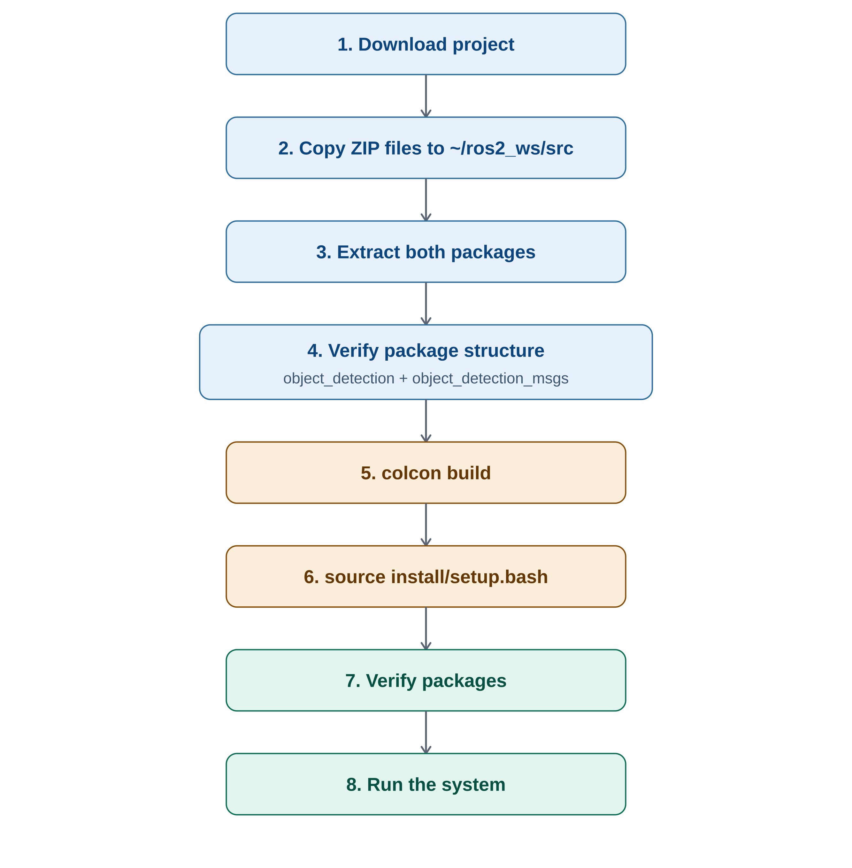
Figure 2 — End-to-end installation workflow

4. Running the Package

Building the DepthAI ROS Driver
Clone the repository.
cd ~/ros2_ws/src
git clone https://github.com/luxonis/depthai-ros.git

Return to the workspace and build.
cd ~/ros2_ws
colcon build --symlink-install

Source the workspace.
source install/setup.bash

The object detection system can be executed in two different ways depending on the application.
Method | Recommended for
Individual nodes | Development, debugging, testing
Launch file | Daily operation, deployment

Method 1 — Running Individual Nodes
This method provides greater flexibility and is recommended during development, since each node can be started independently.

Step 1 — Source the ROS2 workspace
source /opt/ros/humble/setup.bash
cd ~/ros2_ws
source install/setup.bash

Step 2 — Start the OAK-D camera driver
ros2 launch depthai_ros_driver_v3 driver.launch.py
The camera driver publishes:
Topic | Description
/oak/rgb/image_raw | RGB image
/oak/stereo/image_raw | Stereo depth image
/oak/rgb/camera_info | Camera calibration

Step 3 — Verify camera topics
ros2 topic list
Expected topics:
/oak/rgb/image_raw
/oak/stereo/image_raw
/oak/rgb/camera_info

Step 4 — Run object detection
Open another terminal.
source /opt/ros/humble/setup.bash
cd ~/ros2_ws
source install/setup.bash
ros2 run object_detection inference_node

Step 5 — Verify the detection topic
ros2 topic list
Expected output:
/detections
View detections:
ros2 topic echo /detections
Example output:
header:
stamp:
sec: 1784181506
nanosec: 949150779
detections:
- class_name: no_parking
confidence: 0.94
distance: 0.80
xmin: 374
ymin: 209
xmax: 410
ymax: 251

Method 2 — Running Using a Launch File
For deployment, it is preferable to start all required nodes using a single launch file.
Advantages:
- Single command startup
- No need to open multiple terminals
- Easier deployment
- Cleaner workflow
- Standard ROS2 practice

Launch Architecture
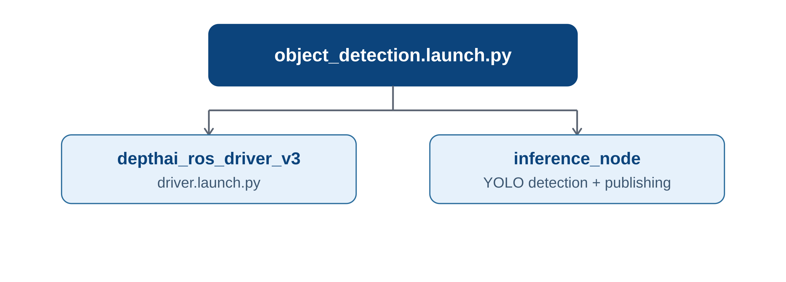
Figure 3 — Launch file architecture

Launch the Complete System
ros2 launch object_detection object_detection.launch.py
This single command automatically:
- Starts the OAK-D camera driver.
- Initializes the stereo depth stream.
- Starts the YOLO inference node.
- Displays the annotated detection window.
- Publishes detections on /detections.

5. Package Structure
object_detection/
├── detector.py
├── inference_node.py
├── visualization.py
├── utils.py
├── models/
│ └── last.pt
├── launch/
│ └── object_detection.launch.py
├── package.xml
├── setup.py
├── setup.cfg
└── resource/

6. Package Responsibilities

detector.py
Responsible for:
- Loading the YOLO model
- GPU selection
- Running inference
- Confidence thresholding
- IOU thresholding
- Returning Python dictionaries
Output format:
[
{
"class_id": 16,
"class_name": "no_parking",
"confidence": 0.93,
"bbox": [x1, y1, x2, y2]
}
]

visualization.py
Responsible for drawing bounding boxes, labels, confidence, and distance using OpenCV. Example on-screen overlay:
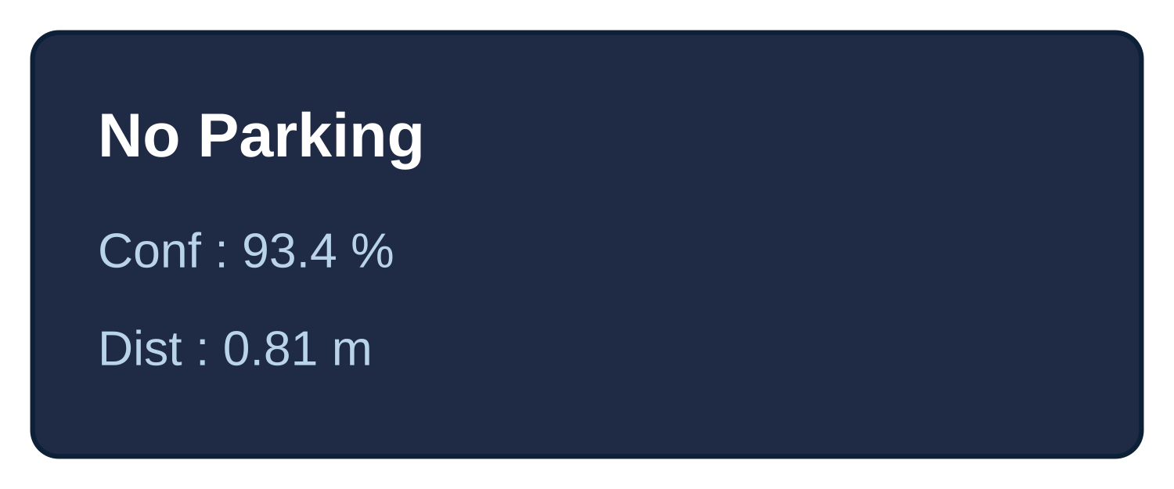
Figure 4 — Example detection overlay

Continue...

utils.py
Contains helper formatting functions.
format_confidence()
format_distance()
Output:
93.6 %
0.82 m

inference_node.py
This is the heart of the package. Responsibilities:
- Subscribe to the RGB image
- Subscribe to the depth image
- Run YOLO
- Estimate distance
- Publish ROS messages
- Display visualization

7. ROS Topics

Subscribed Topics

RGB Image
Field | Value
Topic | /oak/rgb/image_raw
Type | sensor_msgs/Image
Encoding | bgr8

Stereo Depth
Field | Value
Topic | /oak/stereo/image_raw
Type | sensor_msgs/Image
Encoding | 16UC1
Depth unit | millimetres

Published Topics

Detection Topic
Field | Value
Topic | /detections
Type | object_detection_msgs/DetectionArray

Contains:
- Object class
- Confidence
- Distance
- Bounding box

8. Custom Messages

Why Custom Messages?
ROS already provides image messages but does not provide a message specifically for object detections with confidence, class names, and distance.
Instead of publishing multiple independent topics (class, confidence, distance, bbox), we bundle all related information into one structured message.
Benefits:
- Cleaner API
- Easier to subscribe
- Extensible
- Compatible with downstream planning and navigation nodes

Detection.msg
std_msgs/Header header
string class_name
uint16 class_id
float32 confidence
float32 distance
int32 xmin
int32 ymin
int32 xmax
int32 ymax

Field Descriptions
Field | Description
header | ROS timestamp and frame ID
class_name | Human-readable object label (e.g., stop, no_parking)
class_id | Numeric class ID from the YOLO model
confidence | Detection confidence (0.0 - 1.0)
distance | Estimated object distance in metres
xmin, ymin, xmax, ymax | Bounding box pixel coordinates

Example:
header:
stamp:
sec: 1784181506
nanosec: 949150779
frame_id: oak_rgb_camera_optical_frame
class_name: no_parking
class_id: 16
confidence: 0.94
distance: 0.80
xmin: 374
ymin: 209
xmax: 410
ymax: 251

DetectionArray.msg
std_msgs/Header header

Detection[] detections

Purpose
Allows multiple detections to be published in a single ROS message for each image frame.
Example:
header:
frame_id: oak_rgb_camera_optical_frame
detections:
- class_name: stop
confidence: 0.95
distance: 1.22
- class_name: speed_limit_30
confidence: 0.91
distance: 2.84
- class_name: no_parking
confidence: 0.87
distance: 0.79

Continue...

9. Detection Pipeline
The diagram below summarizes the full per-frame detection and distance-estimation pipeline.
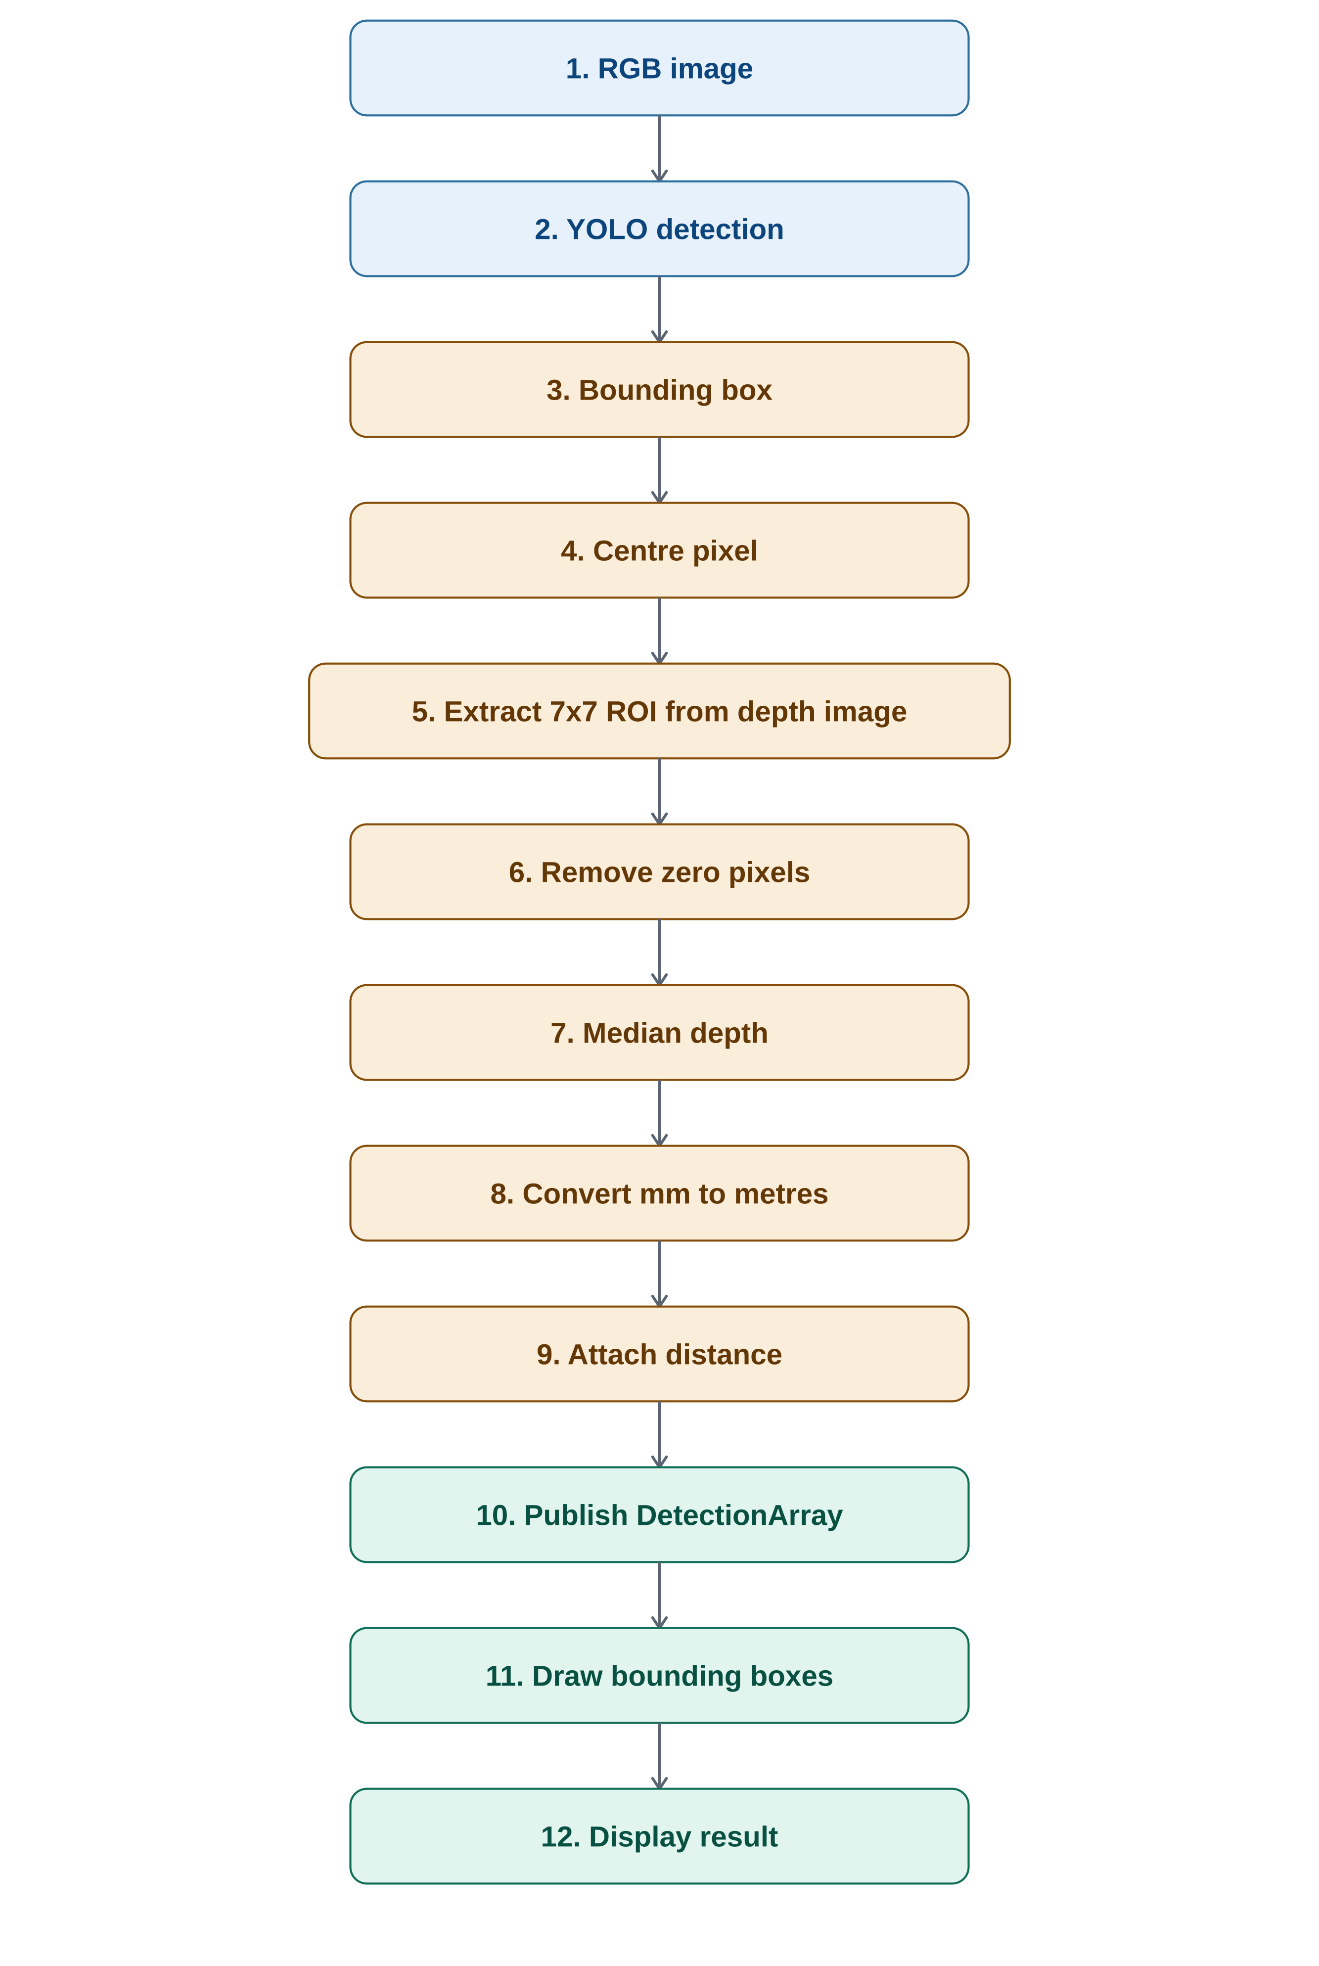
Figure 5 — Per-frame detection pipeline

10. Distance Estimation
The distance estimation process uses the synchronized stereo depth image published by the OAK-D camera.

Step 1: Compute Bounding Box Centre
The centre pixel of the detected object is calculated as:
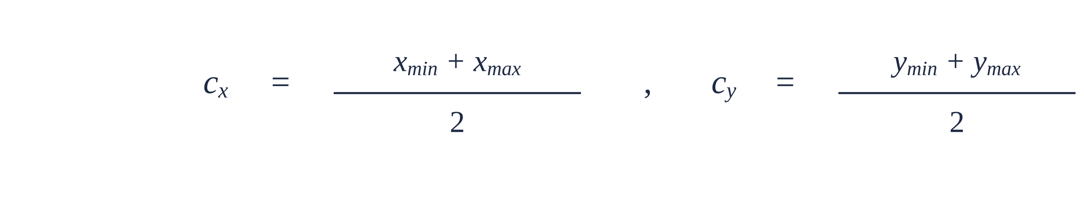

Step 2: Extract a 7×7 Region of Interest (ROI)
A 7×7 window centred at the bounding-box centre is extracted from the depth image to reduce sensitivity to noisy pixels.

Step 3: Remove Invalid Pixels
Depth values equal to zero are discarded because they represent missing measurements.

Step 4: Compute Median Depth
The median of the remaining valid depth values is used:

Using the median instead of the mean provides robustness against outliers.

Step 5: Convert to Metres
The depth image stores values in millimetres. The final distance is:

